What to expect at your Cardew Physiotherapy & Performance appointment

- Stop – knock and wait outside, at a distance of 2m from the door.

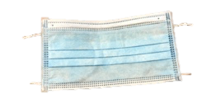
- Mask – bring your own face covering and have it ready to wear.

- Temperature – you must not have a ‘fever’, and you will need to have completed your screening questionnaire.
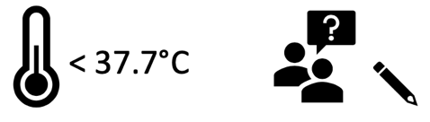

- Entry- follow the therapist into the clinic when asked.

- Hand decontamination prior to sitting.

- Maintain a 2m distance whilst history taken.
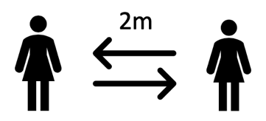

- Treatment.
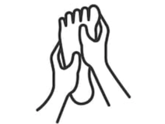

- Exit – you will leave the clinic as soon as your treatment is complete.
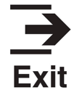

- Cleaning- the room and surfaces will be cleaned, and PPE changed.

- Electric reporting and billing- all patient notes; exercises; letters and billing will be online. Cash can not be used.

